The creator
March 9, 2021
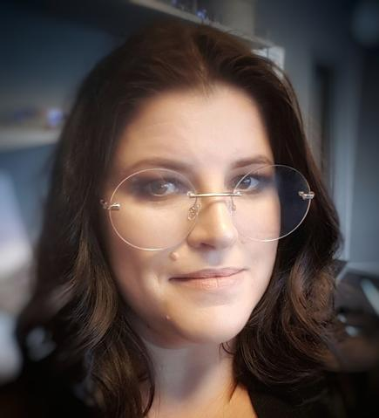
Stina Urberg - designer, jewelry artist and founder of Urberg Design
Growing up in the middle of artisans, artisans, handicraft traditions and "1000 artists" in the northernmost parts of Ångermanland, where design, creativity and creativity as well as the surrounding nature came early to shape me.
From my upbringing, I brought with me a broad knowledge of materials and a creative interest that I today call a need "as important as a life-sustaining organ", which drives me big and small.

"Starting point and education"
Early on, I chose to take the creative path in life. The choice of upper secondary school was a matter of course that later led on to a folk high school with an artistic focus.
A curiosity about materials and techniques has always existed over the years and made me take all kinds of courses via student unions and also through other creators had the opportunity to try out their field. It is a curiosity that never seems to subside and it feels reassuring as I see the source of my zest for life largely lies in my creativity, creativity and curiosity.
A degree in Archeology and Museology (museum science) was the result of a quest for knowledge about and an interest in history, prehistory, man, traditions, heritage, culture, nature and the environment.
Creativity, design and creativity as interest, passion and need have over the years steadily grown and required an increasing space in my life.
As a designer and creator, I weave together my knowledge, experiences and interests with a desire to offer climate-smart, skin-friendly, personal, rustic, soulful, timeless and unique jewelry.
For 20 years I have designed and created jewelry regularly on a part-time basis under the signature "Urberg Design". I have largely used the technology and craft tradition called Luffarslöjd / Trådtjack. A technology that in my opinion has a very interesting history, as the name suggests.
Simply explained, it is about using simple and few tools to shape and tie metal wire. Originally, utensils were created, but toys and decoration also appeared.
With a starting point in just that technique, I have since taken the craft with metal wire on to my own expression and design language.
Traditionally, it is iron wire that has been used and it is also the material I fell for.
The iron, the raw, as untreated, from the outside environment can get everything from a deep and shiny luster of, for example, body-friendly use or to get a tarnished and corroded surface when the iron is exposed to both moisture and oxygen.
It immediately turned out that there was interest and a demand for my mentioned products.
Jewelry from Urberg Design has over the years been sold in design, handicraft, handicraft and seasonal stores. They have also been shown and / or sold at county museums, art galleries.
Over the years, with Urberg Design I have also participated in many genuine craft markets.
The passion, the knowledge, the interest, the experiences, the curiosity, the drive, the design language and the dreams were so intertwined in one company.
With my jewelery art, I offer the market alternatives to the mass-produced jewelery, in the prevailing fixed fashion, wear and tear and over-consumption of raw materials that we have learned over time, from the major players in the market.
Circular entrepreneurship, for me, in my company, I have liked two invisible, but anything but quiet, colleagues who work by my side, they are called "form & style" and "sustainability". Sustainability in its most inclusive form.
"No one can do everything, but everyone can do something" and "together we are strong" - have become clichés but are certainly no less true for it!

"Re-use" and "secondary surfaces"
Ever since growing up, re-use, or "re-use" as it was then called, has had an obvious and natural place in everyday life, in thought and action.
Recycling became increasingly important to me. As an adult, it came to mean something bigger, get a higher value. A global consciousness seen from my small place on earth. An awareness that also led to choices in both private and professional life.

"The pursuit of skin friendliness"
The interest in skin-friendly materials has its simple explanation in being just me and being nickel-hypersensitive, while at the same time feeling like and wanting to be able to decorate contributed to the fact that already in my younger teens I sought solutions to be able to wear (which in my opinion then, were cool and stylish) jewelry. By using parts of purchased jewelery and creating my own jewelry details through all kinds, more or less possible or impossible, recyclable materials and through various handicraft techniques, I designed and created my own unique jewelry early on.
For many years I have been interested in creating jewelry in metal and I have found materials that are skin-friendly, both to wear but also to work with, which is an obvious prerequisite.
Glad you read about me, the designer and creator behind Urberg Design's jewelry art!
/ Stina U

